We Still Remember Them
Twenty-one years after the end of the Great War, the War to end all Wars, Great Britain found itself again involved in a global conflict that was to last six years. Surprisingly, there was no war memorial plaque recording the names of the men who died in the Second World War placed in Church to commemorate their sacrifice. The First World War Memorial, made by Hardman, had also been lost during a major restructuring of the Church. Andrew Lloyd, a curate at St. Werburgh’s 1987-91, with a group of parishioners, took on the task of researching the names of people who should be commemorated in the War Memorial Chapel. On 30 May 1990, there was re-dedication service held at St. Werburgh’s at which two new war memorial boards were placed in the War Memorial Chapel. One commemorated those who had died in the Great War and a second parish members who had died in the Second World War and later conflicts, Korean War and Northern Ireland. The people who died during World War 1 are commemorated in the book, “We Shall Remember Them” published in 2015. This essay recalls those who made the supreme sacrifice in the Second World War and later conflicts. It has used as its primary source material the names found on the board in the War Memorial Chapel and the stories are written in the order of the names cited. Names of civilian casualties who died as the result of bombing raids conducted against Chester are also included. Unfortunately, information has not been found for all the names identified as casualties by Fr. Lloyd.
The Second World War 1939-45
Vincent Campion Royal Marine died 1942 – No such name identified on CWCG
This name may have been mistakenly placed in the WW2 list. John Vincent Campion, known as Vincent, was a Royal Marine. His death was recorded on the WW1 Memorial Board and his name is in the book “We Shall Remember Them”. Bernard Gerald Campion, Vincent’s youngest brother born in 1914 went to St. Werburgh’s school and also entered the navy where he served for 12 years. Whilst serving in H.M.S Prince of Wales he took part in operations which resulted in the sinking of the German Battleship Bismarck. He was later a surviving crew member when the Prince of Wales was sunk by Japanese aircraft. A few days after the fall of Singapore, his parents received a telegram saying he was well and a prisoner of war. He was attached to the Singapore Naval base, H.M.S. Sultan, at the time. Gerald survived the war and died in 1996 at Plymouth, Devon.
James Conlon Pte Durham Light Infantry – Died 1944, aged 24 -Service Number 4129709
James Conlon, son of Michael Patrick Conlon and Mary Ellen Harvey, was born 3 November 1919. The 1939 Census taken just after the outbreak of the war shows James living with his widowed mother at 1 Seaville Buildings, his occupation is given as Steel Window Frame Worker, out of work. It is likely he volunteered soon after the outbreak of the war as the report of his death in the Chester Observer August 1944 indicates he had been serving in the Forces for four and a half years and had served with the Cheshire Regiment with the Eight Army throughout the Middle East Campaign. Following this campaign, James must have been returned to England where he trained for the invasion of Europe with the 9th Battalion Durham Light Infantry. He died, 14 June 1944, and was buried at Bayeux, Departement du Calvados, Basse-Normandie, France. At the time of his death James elder brother Thomas, born 1909, was serving with the Royal Artillery in Burma.
The Conlon family had a strong military background. Their father, Michael Patrick had grown up in 5 Davies Court and later 22 Steam Mill Street, the son of Irish parents. He had attested with the 3rd Battalion Cheshire Regiment, in 1896 when he was only 18 years old but then transferred to 3 Battalion the King's Own (Royal Lancaster) Regiment. It was with the Royal Lancaster’s that he won the South Africa Medal with 7 Clasps. He served in the Great War was severely wounded and was invalided out after 23 years serving in the Army. His funeral was at St. Werburgh’s in 1936, he was buried with Full Military Honours.
Albert Coursh Died 1941 - No such name identified on CWCG nor evidence of his death in Chester Newspapers
Francis (Frank) Cox Died 1940, aged 49 – D/28815 Pte South Lancashire Regiment (Prince of Wales Volunteers), 6th (Home Defence) Battalion.
Francis, son of Thomas Francis and Elizabeth Mary Jackson, was born 28 Aug 1889 in Everton. Lancashire. In 1920 he married Lily Cox, of Newtown, Chester and they lived at 5 Wellington Street. No records have been found for his volunteering to serve in the 2nd World War. He served with the 6th Home Defence Battalion. Sadly, he was knocked down by a car on the Backford Road on August 30th and died at the Military Hospital, Moston three days later aged 49 yrs. He had served four years active service in the last war and came through without a scratch. He left a widow and five sons. He was buried on the 7th September 1940. Father Irish officiated at the service held at St. Werburgh’s.
Francis Cox appears to have had a colourful life. The Catholic Baptism records of St. Joseph, Liverpool show he was born 28 August and was baptised 15 September the same year. A later baptism may also be found in the Parish Baptism Register of St. Chad, Liverpool. Here, his date of birth is shown as the 29 August 1889 and his baptism date given as 21 October 1891.
Francis was buried in Overleigh Cemetery, the grave is marked by a CWCG
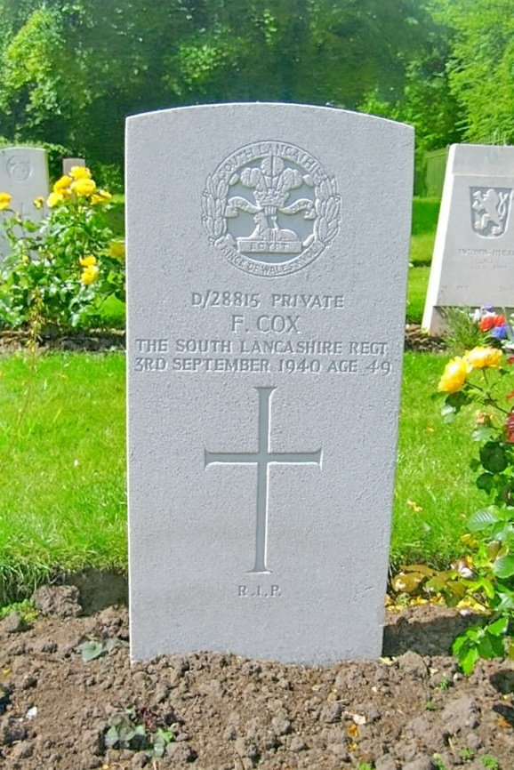

Captain Cox Died 1942
Only one name, Captain Richard Beckford Cox, identified on CWGC Register. Service number 104701, Royal Army Ordnance Corps. Date of death 5 May 1942, buried or cremated at Dunbarney Cemetery, Grave 477, United Kingdom. Son of Algernon Charles Cox and Gertrude Lilian Cox. Baptised St. Mary, Bryanston Square, Westminster, 9 March 1914. 1939 census gas the family living at New Windsor, Berkshire. Father was a Local Bank Director; Richard Beckford was a stockbroker. There is no evidence found of his death in Chester Newspapers. It is likely this is not the person referred to on the current War Memorial Board.
Ernest Anthony Dempsey Died 1944 aged 21 – Service Number 1494695 Sergeant Wireless Operator/Gunner – Coastal Command
Ernest, son of John and Winifred Emma Dempsey (nee Wallace), born 5 March 1923, Tynemouth. Husband of Pamela Sheila Joan Dempsey, of Newton, they lived at 65 Halkyn Road, Chester. Died 6 April 1944 whilst flying from Silloth, Cumberland. He was a member of No 6 Operational Training Unit flying a Wellington X11, a maritime version of the Wellington and crashed into the Solway Firth during a daylight-controlled descent through cloud exercise. He was Buried Silloth (Causewayhead) Cemetery, Holme Low. A personal inscription on the grave states
In Spirit Still He Lives, Flying With His Comrades Wing To Wing In Flight
Bernard Emmett Died 1944 aged 22. Private in the Kings Liverpool Regiment. His Service Number was 3782008.
Son of Albert Edward Emmett and Margaret Gibbons, b 25 Dec 1921. Bernard was attached to the 5th Army Film Photo Section at the time of his death. He died at sea on the 6 June 1944, the day of the first landings in Normandy. His name is commemorated at the Bayeux War Memorial Cemetery. He attended St. Werburgh’s school and had been in the Forces for about three years. Before the war Bernard had been employed at Brookhirst Switchgear Ltd.
His eldest brother, John Emmett, a Chester Corporation employee, who served with the Royal Engineers was evacuated from Dunkirk and later invalided from the Forces. At the time of his death, Bernard’s brother Driver Joseph Emmett was a Prisoner of War in Thailand. 1944 was a terrible year for his mother as two of his step-brothers, Hugh Bernard Croghan and Thomas John Croghan also died that year in Italy.
Hugh Bernard Croghan Died 1944 aged 21. Private in the King's Own Yorkshire Light Infantry. His Service Number was 4698265.
Son of Hugh Croghan and Martha Rogers, b 1922. Hugh Bernard’s father, Hugh Croghan had joined the Cheshire Regiment 1 Sep 1914 and had served with the British Expeditionary Force in France and had suffered gun shot wounds in the left arm and right leg. It is not therefore surprising that Hugh, his brothers and step brothers all served in WW2. Bernard was educated at St. Werburgh’s school and worked at the Reliance works before joining up in 1941. Bernard served with the 2/4th Battalion, King's Own Yorkshire Light Infantry. He died 21 Jan 1944 and is commemorated at the Minturno War Cemetery, Minturno, Provincia di Latina, Lazio, Italy.
Thomas John Croghan Died 1944 aged 23. Trooper, Royal Armoured Corps. His Service Number was 7904917.
Eldest son of Hugh Croghan and Martha Rogers, b 18 Apr 1921. Thomas went to school at St. Werburgh’s and was a member of the St. Werburgh’s Folk Dancing Club. At the age of 14 he became an apprentice fitter at Brookhirst Switchgear Ltd until he left to join the army in early 1941. In 1942 he went to the Middle East and took part in the fighting at El Alamein and Tobruk and was in the whole Tunisian campaign. Thomas was killed in action 10 Nov 1944 and is commemorated at the Ravenna War Cemetery, Ravenna, Provincia di Ravenna, Emilia-Romagna, Italy.
John Terence Croghan Died 1945 aged 19. Private, East Lancashire Regiment. His Service Number was 14713265.
Only son of John Michael Croghan and Olive Victoria Coe, b 27 July 1925. His father was educated at St. Werburgh’s school and served in the First World War with the Machine Gun Corps. The parents married in 1918 and had four children. In the time of the great depression in the inter war years, John Michael Croghan was unemployed, it was only in 1936 that he obtained regular employment on the railways. Despite this set back, in May 1960, John Terence’s father at the Annual meeting of the Chester City Council was elected Mayor of Chester. John’s parents lived at 31 Oak Road, Lache Estate, and he was educated at St. Anthony’s School, Saltney, and attended St. Anthony’s Church Saltney, serving as an altar boy. Before joining the forces, he was employed at the L.M. & S goods department where he had been since he was 16. John Terence joined the army aged 19, Feb 1944 and went abroad 6 months before his death from head wounds. He is commemorated at the Becklingen War Cemetery, Soltau, Heidekreis, Lower Saxony, Germany.
George Ernest Coe Died 1944 aged 33. Flight Sergeant Royal Air Force Volunteer Reserve. His Service Number was 1126098.
Son of Ernest William Coe and Elizabeth Parry, b 17 May 1910, baptised, St. Mary Without-The-Walls, Handbridge, married Irene Fletcher 10 May 1941. He was a cousin of Hugh Bernard, Thomas John and John Terence Croghan and Bernard Emmett who all died serving their country abroad.
In the 1939 census, George Ernest’s occupation is shown as a hair dresser. George joined the Royal Air Force Voluntary Reserve.
George was attached to Royal Canadian Air Force Squadron 432 (Leaside). During WW2 it was not unusual for RAF personnel to be attached to RCAF as this sharing of resources was deemed to maximise effectiveness.
Handley Page Halifax, Mark III, NA500 QO-G took off from RAF East Moor at 22:57 hrs for mission at Boulogne Railway Yards. The aircraft is thought to have collided with a 427 Squadron Halifax LW114 ZL-S. Both aircraft crashing between le Portel (Pas de Calais) in the North West outskirts of Outreau and South West of the entrance to Boulogne sur Mer harbour. This was the aircraft first sortie. George Ernest is buried at the Calais Canadian War Cemetery, Leubringhen, Departement du Pas-de-Calais, Nord-Pas-de-Calais, France. John Terence’s role on the mission was indicated as Bomb Aimer.
Other sources indicate his Trade was Wireless Operator/ Air Gunner. It is likely that he was trained in multiple roles due to the urgent need for versatile crew members.
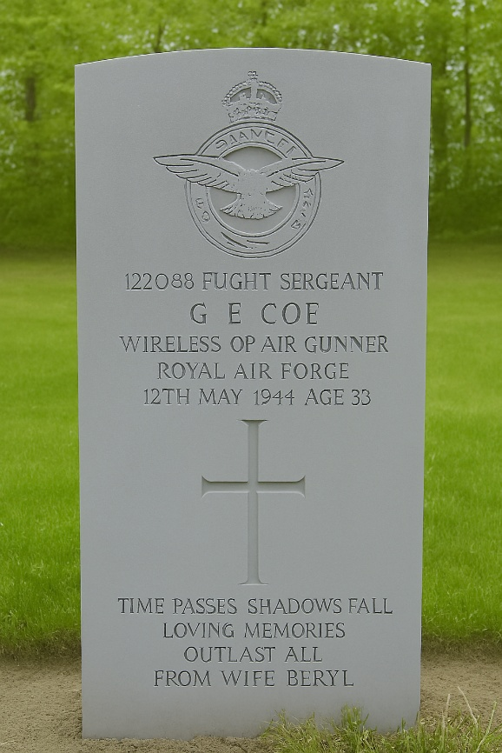
Handley Page Halifax III

Joseph Patrick Gallagher Died 1944 aged 27. Lance/Corporal Lancashire Fusiliers. His Service Number was 3456890. 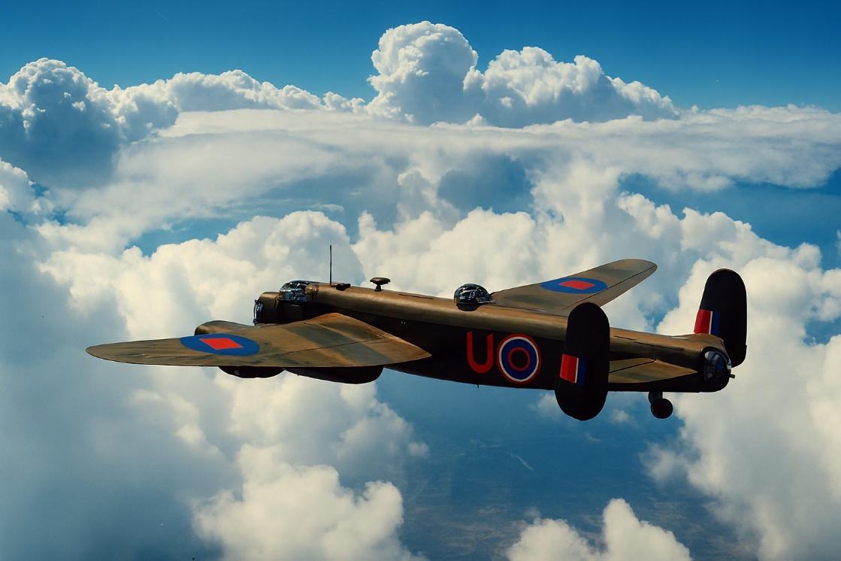

Son of Francis Gallagher and Alice Crawley, b 9 Apr 1916. Joseph served an apprenticeship at Messrs. John McKay and Sons Ltd, 8 Queens Street. He was assistant secretary of Chester Labour Party for about five years and stood as prospective candidate for St. Oswald’s Ward in 1939. He was also secretary of the League of Labour Union and a member of the League of Nations Union. In 1940 he joined the Army and was sent abroad two years later. Lance/Corporal Gallagher was killed in action 8 May 1944 whilst serving with the forces in Burma. He was married to married to Doreen O’Rourke and had a daughter Elizabeth. His brother-in-law, Alexander Terence O’Rourke had died earlier in the war.
William Gannon Died 1944 aged 20. Private 1st Bn. King's Own Scottish Borderers. His Service Number was 14402834.
One of three sons of John and Elizabeth Burkhill, b 8 Jan 1924. An elder brother, John (Jack) Gerrard served with the RAF in South Africa. William’s grandparents, John Gannon and Catherine Kivil, came to Chester from County May. William was educated at St. Werburgh’s school and then was an apprentice at Brookhirst Switchgear before joining the Forces in 1941. He died 13 Jun 1944 and is commemorated at the Hermanville War Cemetery, Hermanville-sur-Mer, Departement du Calvados, Basse-Normandie, France.
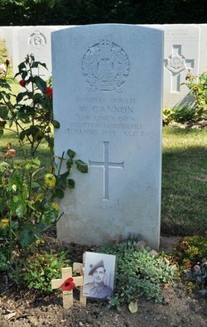

Edward Valentine Hemryk Died 5 May 1941 aged 56 Lieutenant Colonel Pioneer Corps. His Service Number was 22423
Paul E.J. Hemelryk was a naturalised British subject born in Holland; and came to Liverpool in 1862. He became a prominent Liverpool cotton broker who was decorated with honours from both the Pope (Knight Commander of St. Gregory) for his charitable work and by the Emperor of Japan (for his work as the Japanese consul in Liverpool). A number of his sons entered the Forces and reached high rank. Paul Henry Hemelryk, the eldest son rose to be Lieutenant Colonel of the King's (Liverpool Regiment) in WW1. He purchased Christleton Hall, late 1926 and lived there until he sold the Hall to the Salvatorian Brothers in 1934. He was Colonel in Charge of the City of Chester Home Guard Battalion until he retired on reaching the age limit in 1941. It is this close connection of St. Werburgh’s with this Christleton Hall family that there are two members of the Hemelryk family remembered on the War Memorial Board.
Edward Valentine Hemelryk was a younger brother of Paul. He was educated in England, France, Germany and studied commerce in Spain. When only twenty-one he joined the 4th West Lancashire Artillery Volunteers; and during the European War gained the D.S.O., was mentioned in despatches. In 1916 he was promoted a Major with the Royal Field Artillery and served in that role until sustaining injuries 22 April 1918.
For many years after the war, he commanded 59th Medium and 87th Field Brigades of the Royal Artillery successively. He was promoted Colonel 14 May 1929, a position he held until 30 Aug 1931. Edward Valentine returned to active service in WW2 and was killed in the Fire Raid on Belfast 5 May 1941 when serving as a Major with the Pioneer Corps. 13 members of No. 173 Company, died that night as bombs fell on their billets at No. 24 (London) General Hospital, Campbell College.
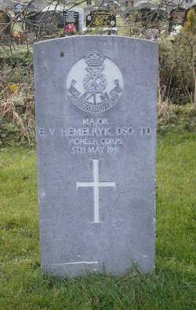

Anthony Hemelryk Died 1942 aged 21 Lieutenant Royal Navy His Service Number was 3456890.
One of four sons of Paul Henry Hemelryk and Dorothy Counsellor of Christleton Hall. All four sons joined the Forces.
Anthony, the youngest of the sons, was the only one of the sons to die in WW2. He died 12 Dec 1942. He had joined the Forces as a Royal Navy cadet at Dartmouth January 1935, passing out 1 Sep 1938. After a training cruise on “H.M.S. Vindictive” he was appointed 1 May 1939 as mid shipman to the Royal Sovereign. For a time, he served on battleships and cruisers. When promoted sub-lieutenant, 1 Mar 1941, he volunteered for duty in submarines. He returned to surface craft and took part in engagements at Dakar, Taranto and off the Norwegian Coasts. Later he returned for duties on submarines. In early 1943, Anthony’s parents received official notification that their youngest son serving as 1st Lieutenant on H.M. Submarine P222 was missing and presumed dead. P222 left Gibraltar for a patrol off Naples on 30 November 1942. Messages were received from her on 7th December but after that date no more was heard. P222 failed to arrive at Algiers and was reported overdue on 21 December 1942. The Italians claimed to have sunk a submarine by depth charging from the Italian torpedo boat Fortunale on 12 December, south-east of Isola di Capri. This is the most probable cause of the submarine’s loss.
Anthony Hemelryk is remembered on the Portsmouth Naval Memorial. The date of death on the memorial is shown as 21 Dec 1942.
A photo of P222 is shown below. The submarine was sunk before she was given a name.
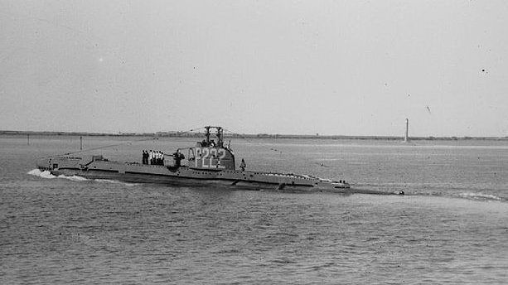
Zygmunt Kedjerski Died 1940 aged RAF Polish Squadron
See Civilians who died by enemy action
John McGinn Died 1945 aged 39 Bombardier, Regiment Royal Artillery. His Service Number was 1656370.
John (Jack) McGinn, the eldest of three sons of Thomas and Catherine McGuinn (nee Hunt). Both parents came from Gorteen, Sligo and married in Chester. They lived at 17 Back Brook, Street. John was born 19 March 1905 and baptised at St. Werburgh’s by Canon Chambers. His brother Thomas born 1910 unfortunately died in 1912. His youngest brother, Charles Patrick McGuinn, b 6 Feb 1912 married Margaret McCleary, 1939. Jack McGuinn sadly died 3 May 1945, only five days before the end of the war in Europe. CWGC indicate he is Buried or Commemorated at Uden War Cemetery, 6.C.8., Netherlands. During the occupation allied casualties were buried in the parish priest's garden. In 1943 the municipality acquired the Roman Catholic Cemetery which was out of use since 1918. After the war about 100 graves were moved from the garden into the new cemetery. Many other graves from the region were also moved to the cemetery. The Uden War Cemetery Commonwealth War Graves Commission cemetery was established in 1960 and is home to 703 graves from the Second World War.
Alec McGregor Died 1943 - No such name identified on CWCG nor evidence of his death in Chester Newspapers
John McNamarra Died 1944 aged 34. Leading Stoker Royal Navy. His Service Number was D/KX. 80450
Thomas McNamara, the eldest two sons of Thomas and Elizabeth Massey, both of whom were killed in action during WW2. John was educated at St. Werburgh’s school and was employed at the L.M.S Railway before joining the Navy in 1930. He served for 3 years on H.M.S. Rodney before the outbreak of the war. In 1941 he was mentioned in despatches for valour and devotion to duty during a bombing attack on his ship, H.M.S. Terror. He saw action at Tobruk. John died 14 May 1942 whilst serving on H.M.S. Trinidad, a Fiji Class Light Cruiser. Arctic convoy, PQ-13, left loch Ewe in Scotland on 10 March 1942, but turned around and headed North towards Iceland as it was rumoured the German Battleship Tirpitz was in the area. On resuming from Reykjavik on the 20 March, the convoy was attacked by U-boats and German destroyers and in the afternoon the convoy was attacked by Junkers 88 Dive bombers and Dornier torpedo bombers. Trinidad escaped except for a few bomb splinters on ‘A’ turret. During the action H.M.S. Trinidad sank the German destroyer, Z 26. Unfortunately, a malfunction with a gyro mechanism, probably caused by the freezing conditions, caused one of its torpedoes to arc and strike the ship, 32 of the crew were killed. H.M.S. Trinidad did not sink and limped into Murmansk for repairs. H.M.S. Trinidad left the Kola inlet for the return journey. Within a few hours they were spotted by an enemy plane and were attacked by 20 Junkers-88 bombers. Trinidad was struck and badly damaged. 63 men were lost including 20 survivors from H.M.S. Edinburgh. Survivors were picked up by neighbouring vessels.
Picture of the ship sinking having been torpedoed by H.M.S. Matchless following decision to abandon ship.
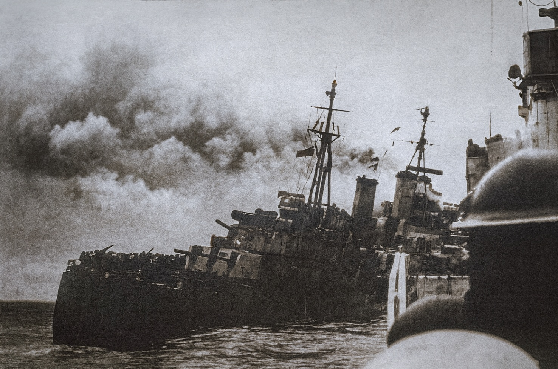
Trinidad Sinking, from one of the rescue destroyers
Frank McNamarra Died 1944 aged 30. Private 6th Batt. Cheshire Regiment. His Service Number was 4131552.
Private McNamara was serving with the Central Mediterranean Forces when he died, 28 Oct 1944. . He had been on active service for four and a half years. He had carried on a business in his own account before joining the Forces. Educated at St. Werburgh’s School, he was a keen swimmer and horse rider. His younger sister, Phyllis, served in the A.T.S. and a brother-in-law, Pte. Leslie Dunn, was a prisoner of war. Frank McNamara’s memorial is found on the Ancona War Cemetery IV. C. 17.
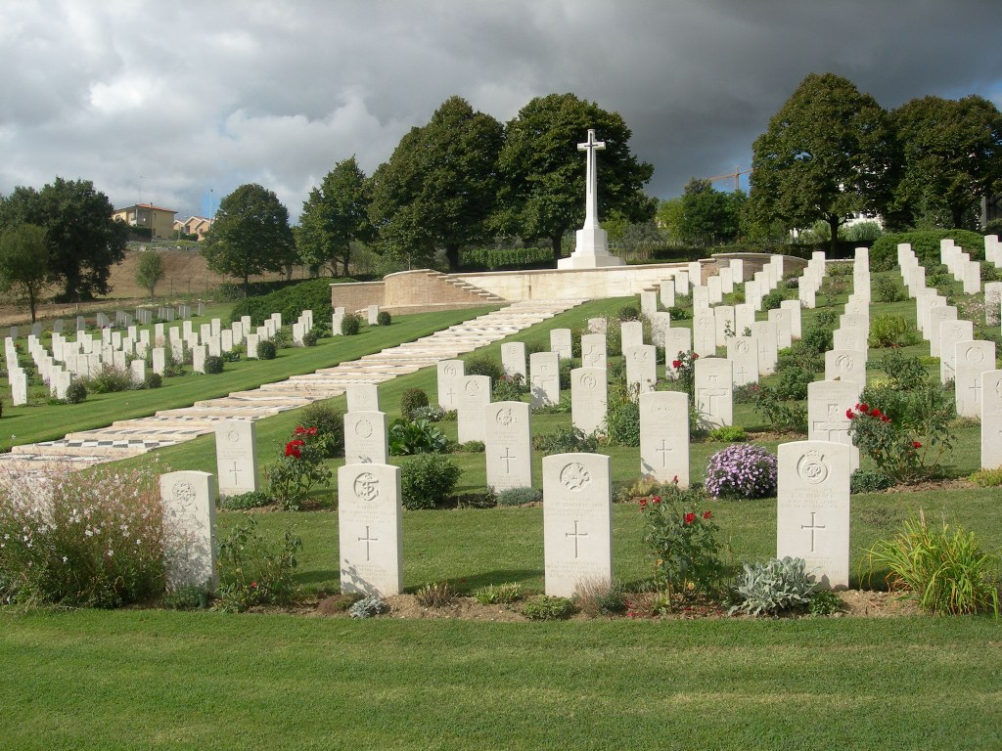
Laurence McNicholas Died 1944 – Pte. No such name identified on CWCG nor evidence of his death in Chester Newspapers
Michael McNicholas Died 1944 – Lte. No such name identified on CWCG nor evidence of his death in Chester Newspapers
Edward Arthur Maloney Died 1943 aged 31 Flight Sergeant 224 Squadron, Royal Air Force Volunteer Reserve, Coastal Command. His Service Number was 1112371.
Arthur Maloney, son of Edward Maloney and Mary Alice Taylor of Buttevant, Cork. the eldest of four brothers. Before joining the Forces, he had worked for Bradley’s, Chester Ltd., and the Chester Council. Arthur was a wireless operator, air gunner flying with 224 Squadron, out of St. Eval, Cornwall. Between 23 April 1943 – 11 September 1944, 224 Squadron was flying Consolidated Liberator GR Mk V. These were B-24 Bombers, converted to Anti-submarine operations (Asw) over the Bay of Biscay and attacks on shipping over the French Coast. St. Eval was the home to four RAF Liberator Squadrons, giving the station one of the most powerful anti-submarine forces in the RAF. This force flew thousands of hours of patrols each month and was rewarded with a number of sightings, with at least three confirmed U-boat kills in June alone. Arthur’s plane was shot down by a Junkers 88 in the Bay of Biscay, during an Asw Patrol on the 2 Jun 1943, three of the Crew Survived. Edward Arthur is commemorated on the Air Forces War Memorial at Runneymede. This Memorial stands upon the crest of Coopers Hill overlooking the River Thames and the field of Runnymede where in 1215 King John affixed his seal to the Magna Carta. The war memorial, opened by Queen Elizabeth 11, in 1953 commemorates the shared sacrifice of over 20,000 Commonwealth air force servicemen and women who gave their lives during the Second World War.
Two of Arthur’s brothers, William Ronald and Cyril John, served in the Royal Navy during the War.

Robert Moody Died 1942 aged 28. Able Seaman, Royal Navy. His Service Number was C/JX 253149.
Robert Moody, son of Walter Henry and Alice Maud Rogers, before joining the Forces worked at the General Station. He married Winifred Doreen Mylett at St. Francis’s Church, 5 Jun 1939. His grandfather James Austin Mylett was baptised at St. Werburgh’s. Robert joined the Forces in 1941. He was based as a naval gunner on the MARO MV, a Greek Cargo Motor Vessel of 3,838 tons built in 1924. The vessel left Garston on the 31 Dec 1941 carrying a cargo of soda ash to Halifax. The vessel was attacked by gunfire from U-552 and sunk in the North Atlantic on the 12 January 1942. His name is commemorated on the Chatham Naval Memorial Grave Ref 55, 2.
MARO MV
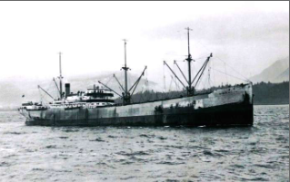
Alexander Terence O’Rourke Died 1941 aged 24. Private Royal Army Medical Corps 4 Light Field Ambulance. His Service Number was 7517873.
Terence O’Rourke, son of James and Elizabeth Massey, born 1916. He was one of twelve children. The information found on Alexander is very limited. He was listed as missing at sea and presumed to have been killed in action 28 April 1941. He was part of the Expeditionary force to Greece. The Commonwealth War Graves Commission show he is commemorated on the Athens Memorial Face 9, Greece. Further evidence is found in 1946 when a dinner was held of Red Cross Veterans. The occasion was the re-union Dinner of Cheshire 7 Detachment at the Ambassadors Restaurant Chester. The Detachment had been founded in 1917 to meet the convoys of wounded brought to Chester and to help serve in the local hospitals and the meeting was ostensibly to commemorate their work. They were proud of the 7th because it was the oldest detachment in the County and one of the oldest in the Country. AT the end of the meeting a special toast was given to three members who had given their lives in WW2. Alexander Terence O’Rourke, who had joined RAMC was one of those remembered. From this it would appear that Terence joined the R.A.M C. because of his previous experience with the Red Cross.
Without access to the relevant records, the following are the likely events that led to Terence O’Rourke’s death with the British Expeditionary Force in the Mediterranean.
German Forces had pushed into northern Greece from Bulgaria and Yugoslavia, with Yugoslavia eventually capitulating 17 April 1941. Although the British were fully stretched fighting the Axis in North Africa, they had dispatched an Expeditionary Force of 58,000 Commonwealth troops to assist the Greeks in March 1941. This force, commanded by General Henry Maitland Wilson, included 1st Armoured Brigade, 6th Australian Division and 2nd New Zealand Division. Despite the brave resistance of the Greek and Commonwealth troops, the speed of the German ‘Blitzkrieg’ overwhelmed their defensive positions. The Germans quickly captured the southern Greek cities and the struggle ended with the fall of Athens on 27 April 1941.
The Allies lost around a quarter of their strength, including 11,000 men captured. Nevertheless, about 45,000 Allied soldiers were successfully evacuated to Crete. German losses were about 11,500, with 2,500 dead. It is likely that Alexander Terence O’ Rourke was lost at sea 28 Apr 1941 as the British Expeditionary Force withdrew from Greece to Crete.
Frank Oliver Reade Died 1944 aged 30. Gunner, 25 Field Regiment, Royal Artillery. His Service Number was 833440.
Frank Reade was the son of William Alberte Reade and Maud Adams, born 28 November 1913. His father, William Albert was a Sergeant with D Battery, 88th Brigade, Royal Field Artillery during WW1. Frank married Catherine Leyden in 1935 and had three children. Frank had first joined the Royal Artillery 1 January 1934. The 1939 census shows he briefly worked as a Postman for General Post Office Chester. He was re-called to the colours in June 1939, and went to France on the outbreak of the war, being evacuated from Dunkirk. He went again to France on D-Day. Frank died 11 August 1944 and is buried Saint Charles de Percy War Cemetery, Departement du Calvados, Basse-Normandie, France.
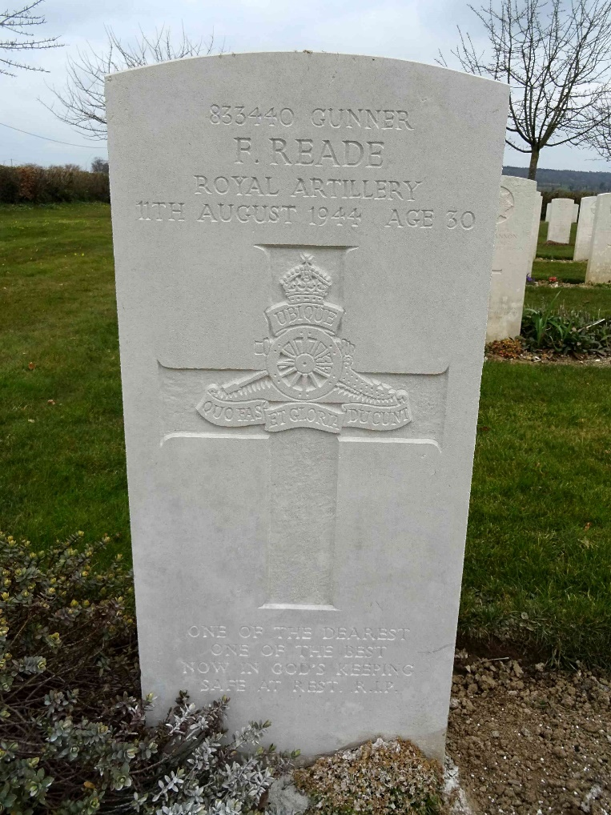

Earnest Roberts Died 1941 – Pte. No such name identified on CWCG nor evidence of his death in Chester Newspapers
John Rook Died 1944 1941 – No such name identified on CWCG nor evidence of his death in Chester Newspapers
Eldred Smith Died 1942 Flt. Lt., Royal Air Force. No such name identified on CWCG nor evidence of his death in Chester Newspapers

Robert Smith Died 1941 No such name identified on CWCG nor evidence of his death in Chester Newspapers
Sydney Joseph Smith 1943 aged 19. Aircraftman 1st Class, 303 Ferry Training Unit, Coastal Command, Royal Air Force Volunteer Reserve. His Service Number was 1678521.
Sydney Smith was the son of Sydney Aloysious Smith and Beatrice Ethyl Jones, living at 25 Heath Lane. Before the war, Sydney had worked for four years with the Co-Operative Society, Chester, as a driver in the milk department. He died in a traffic traffic accident, 2 September 1943, when an R.A.F. vehicle he was travelling in crashed into a Methodist Church at Solva, Pembrokeshire. The vehicle apparently got out of control descending Solva Hill, failed to turn a corner and, turning over on its side, came to rest against the Chapel. Joseph tried to jump clear but struck the Chapel railings and died instantly. At the time of his death, Sydney was based at Talbenny, Pembrokeshire. Sydney was buried in Chester Overleigh Cemetery.
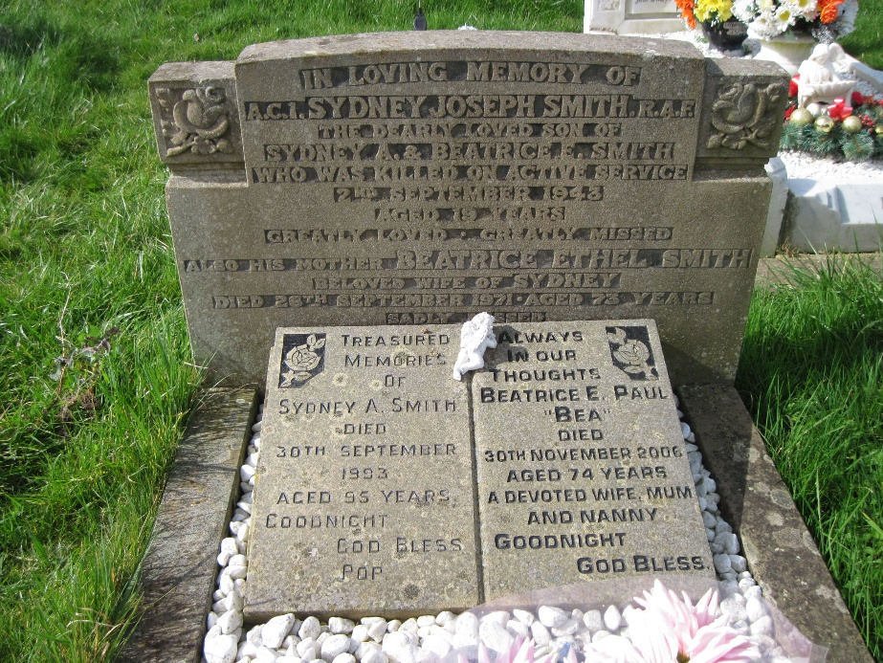

Robert Frederick Tyrer 1943 aged 30. Hong Kong Dockyard Defence Corps. His Service Number was 1678521.
Robert Frederick Tyrer, born Wigan, 20 Nov 1913, son of Robert and Mary Teresa Hammond of 15 Crane Street, Chester. His father had served in France in the Great War with the Royal Garrison Artillery. Robert was educated at St. Werburgh’s School and after leaving school, he joined the Merchant Service for a short time. He attested with the Royal Artillery, Chester Brigade Depot, 2 December 1931 and served with the Royal Artillery for four years, rising to the rank of Sergeant. His service Number was 816633. The newspaper report quotes he served in Singapore, but this may be a mistake. He was transferred to the Army Reserve 1 December 1937 and appears 1 Jan 1940 on W Res and joined the Dockyard Police. Robert Frederick was captured 25 December 1941 The date of his capture suggests he was serving in Hong Kong rather than in Singapore as was quoted in the Cheshire Newspapers. The British Crown colony of Hong Kong surrendered on 25 December 1941. The surrender occurred after 18 days of fierce fighting against the Japanese forces that invaded the territory. Robert was transferred to a Prisoner of War Camp in Japan. The Japanese POW record below shows that he was a Constable with the Royal Naval Dockyard Police.
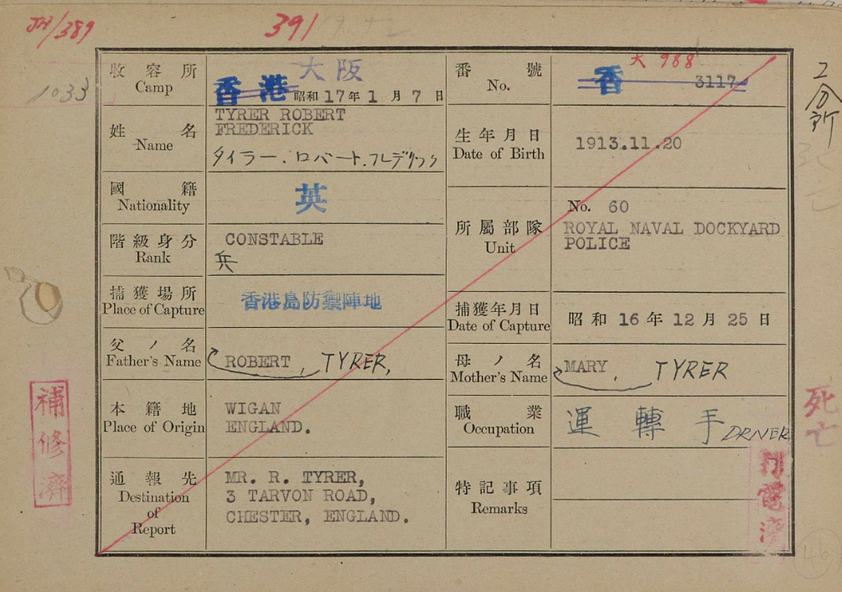
Robert died 10 March 1943 and his name is commemorated on the Yokohama British Commonwealth War Cemetery Hodogaya-ku, Yokohama, Japan. The Cemetery inscription shows he served with the Hong Kong Defence Corps.
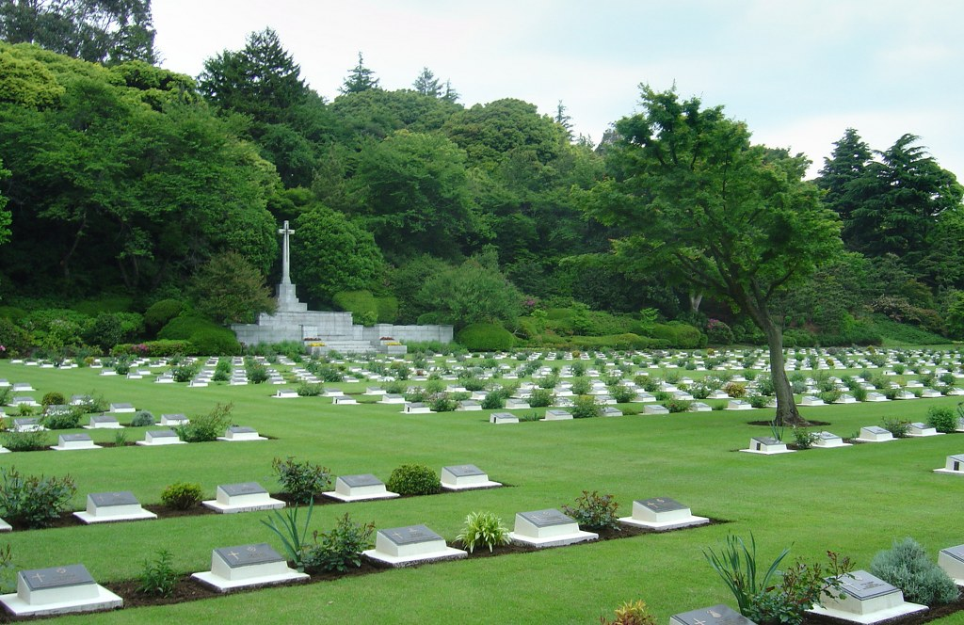
Joseph Mathias Walsh Died 1945 aged 19. 2nd Battalion, Seaforth Highlanders Ross-Shire Buffs, the Duke of Albany's. His Service Number was 14779437.
He was educated at St. Werburgh’s School and was a member of St. Werburgh’s Youth club. Prior to enlisting he was employed by John Summers and Sons Ltd.
Joseph died 24 March 1945 and is buried at Kleve, Kreis Kleve, Nordrhein-Westfalen, Germany in the Reichswald Forest War Cemetery.
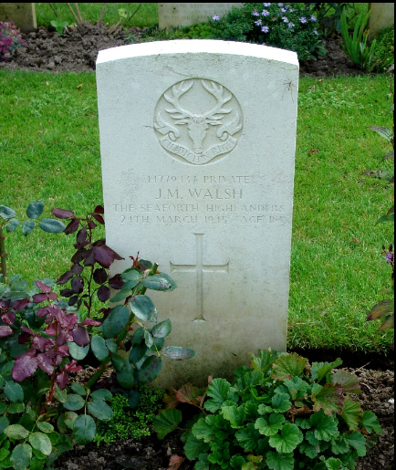
William Arthur Wilcocks Died 1941 aged 22. Trooper, No. 52 Middle East Commando ('D' Bn. Layforce), Royal Armoured Corps. His Service Number was 556474.
Arthur, son of William Ewart and Ellen Roddy, born Chester, 1919. Arthur was enlisted by the Cheshire Yeomanry in 1941 and joined the Royal Armoured Corps. He died 29 May1941 with the commandoes of Layforce. They were being sent from Alexandria to reinforce Cyprus in case of an invasion. Their role was to carry out raids on the German lines of communications with a view to either turning back the invasion or enabling an evacuation to take place. Unfortunately, they were turned back by bad weather and in the next attempt on the night of 26/27 May they were landed at Suda bay in Crete. Almost as soon as they landed, it was decided that they could not be employed in an offensive role and would instead be used to cover the withdrawal route towards Sphakia to the south. As such, upon landing they were ordered to leave all their heavy equipment, including radios and transport, behind. They were poorly equipped for this new role as they were lacking in the indirect-fire-support weapons such as mortars or artillery and were armed only very lightly, mainly with rifles and a few Bren light machine guns. Nevertheless, by sunrise on 27 May they had taken up a defensive position along the main road that led inland from Sphakia. From then until 31 May, they were engaged in carrying out a number of rearguard actions to enable the main body of troops to be taken off the beaches by the navy. Throughout the entire time they were almost constantly under aerial attack. On 28 May the defenders began disengaging from the enemy and withdrawing along the pass through the central mountains that separated them from the port of Sphakia in the south. In the first two nights of the evacuation approximately 8,000 men were taken off.
By 31 May the evacuation was drawing to a close and the commandos, running low on ammunition, rations and water, fell back towards Sphakia too. Laycock and some of his headquarters, including his intelligence officer Evelyn Waugh, managed to get out on the last ship to depart. The vast majority of the commandos were left behind on the island. Although some of them were later able to make their own way back to Egypt. By the end of the operation about 600 of the 800 commandos sent to Crete were listed as killed, missing, or wounded. Only 23 officers and 156 others managed to get off the island. Trooper William Arthur Willcocks died on the 29 May aged 22. He is commemorated at the Suda Bay War Cemetery 13. C. 8., Chania, Crete.
Civilians killed in Chester and Cheshire as the result of enemy action
The parishioners who died in Chester and Chesire includes the names of inmates and staff of the Barrowmore Hospital which was served by the Priests of St. Werburgh’s Parish.
According to reports at the time, an Air raid had begun in Chester at 7.30pm the evening 28th November and continued to about 4.30am. Between 2 and 2.30am in the morning of the 29th November two parachute landmines fell on the village near Barrowmore Hall, one landed on a local farm the other landed just in front of the Hospital resulting in a number of deaths.
Annie Gallagher Died 1940 aged 33.
The severe air raid on 28th November resulted in 21 High Explosive Bombs and 168 incendiary Bombs being dropped on Chester. The Gas Works was slightly damaged, 3 houses were demolished and 15 houses seriously damaged.
Annie, the daughter of Patrick Gallagher and Mary McGeever, born 18 Dec 1907 was injured at Eastgate and died the same day at the Royal Infirmary. She was buried in Overleigh Cemetery, Plot R576.
The 1939 census shows her living with her parents at 52 Victor Street, her occupation was given as housemaid (incapacitated). Her father died 2 January 1940. At the time of her death, Annie was living with her mother in 9 Steven Street.
Patrick Gallagher Died 1940
There is some uncertainty as to whom this name applies.
Patick Gallagher, Annie Gallagher’s father born 7 Jan 1866, County Mayo, died 2 January 1940, aged 73. 1939 census shows he was a builder’s labourer. His name is not mentioned in the Newspapers, nor in the reports of Chester civilians who did from war action. Annie’s father is therefore unlikely to be the person referred to on the War Memorial Board.
An alternative candidate would be Patrick Gallagher, born 28 September 1885, Manchester, died 24 November 1940, aged 54. Patrick lived at Rainbow Terrace, Spittal Walk. His death occurred at the City Hospital. Patrick had served in the Army in India for 11 years before returning to England in 1914. He later served in France until 1916, when he was severely wounded in the arm and legs and was unfit for further service. His death is recorded on the same page of the newspaper as Annie Gallagher above. Patrick died 4 days prior to the bombing raid on Chester and his death is not recorded in the records of civilians who died in WW11. The 1939 census shows Patrick working as a Heavy Worker, Navvy at the Militia Camp. It is possible that he died while working at the Militia camp on war time duty, this would account for his name being recorded on St. Werburgh’s Memorial Board. Unfortunately, no record of this has yet been located.
Barrowmore Hall Sanatorium
Barrowmore Hospital was founded in 1920, when Barrowmore Hall was bought by the East Lancashire Joint Committee of the Order of St. John of Jerusalem and the British Red Cross Society. Barrowmore Hall had been designed by the architect John Douglas (1829-1911). New hospital buildings were erected in 1934. During the Second World War it was also being used as a hospital for ex-servicemen many of whom were receiving treatment for Tuberculosis. Parts of the estate had been given over to the war effort and was being used to build aeroplane parts.
Barrowmore Hall Sanatorium was destroyed by a land mine 29 Nov 1940. William Joseph Cuddy, Ann Gallagher, Sheila Gillen – Nurse and Jeremiah McCarthy, were civilians who died in this incident. Zygmunt Kedjerski who was serving with RAF Polish Squadron also died.
William Joseph Cuddy Died 1940 aged 33.
Son of the late William Cuddy, Queens County, Ireland and Elizabeth Healey, Gorey Co, Wexford, Ireland, was born 23 January 1914. William Joseph, of 18 Maddin Road, Lower Sydenham, Lewisham, London, a landscape gardener, appears to have been a patient at St. Giles Hospital, London who had been transferred to Barrowmore.
Sheila Gillen Died 1940 aged 25.
Sheila’s story as complied by Kieran Gillen and his cousin, Jane.
On the night of the 28th November a young Irish nurse named Sheila Gillen, a native of North Sligo was settling in to her staff quarters after finishing up her shift at Barrowmore Hall. Sheila had travelled to England before the War to join her aunt Kitty to become a nurse like so many other young Irish women. She would be joined later by her sister Joan.
Her aunt Kitty was a nurse in Southport near Liverpool where Sheila would stay until eventually being transferred along with patients and staff to Barrowmore Hall outside Chester. It was believed that by transferring the patients to the countryside around Chester they would be safer. Not long after Sheila first arrived at her new surroundings at Barrowmore Hall she wrote a postcard to her sister Joan that had a photograph of the great old Victorian hall, on the back of the card it read: "This is a photo of the hall, it's quite a lovely old building, all kinds of quaint figures and writings and things on the staircase and hall." The postcard showed a picture of Barrowmore Hall's Victorian façade, on the black and white photo Sheila had marked with a pen the exact window of the room she was staying in.
It is believed that on the night of the 28th November 1940 another young nurse who was sharing a room with Sheila, found it difficult to get to sleep. Believing the bed might be the problem Sheila offered up her bed so her colleague may get a better sleep. Sheila now had the bed closer to the window, tragically this kind gesture towards her work colleague would later prove fatal.
Sheila's earlier act of kindness in swapping beds saved the life of her colleague. In all, eighteen patients and two staff were killed. Sheila's funeral took place at St Werburgh's Church in Chester. In attendance were her aunt Kitty and younger sister Joan, other mourners included a Dr Seymour and the Matron of the hospital representing the medical and nursing staff and a Mr Clarke representing the chairman and committee of Barrowmore Hall. Sheila Gillen's name is listed on the Commonwealth War Graves for Chester Memorial and also on the Civilian War Dead Roll Of Honour 1939-1945 at Westminster Abbey in London. Sheila was buried in Overleigh Cemetery.
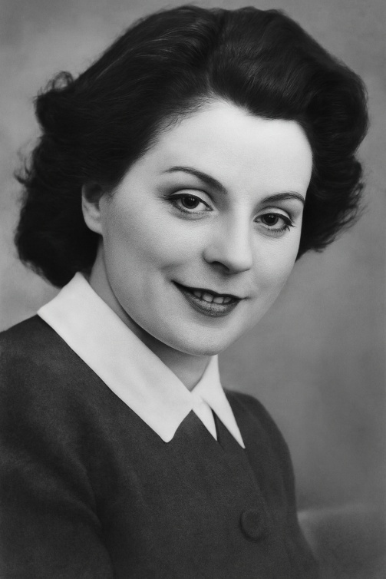

Jeremiah McCarthy Died 1940 aged 25.
Son of Thomas and Hannah McCarthy, of 69 Great William O'Brien Street, Cork, Irish Republic. The 1911 census shows Thomas aged 47 was a Pensioner having served with the Royal Munster Fusiliers and had been married 20 years. It is not certain but it is very likely that Jeremiah’s father was Thomas McCarthy, No 1650 who joined the Royal Munster Fusiliers at Tralee, 6 Aug 1885. He served in India and took part in the Burma Campaign. He was discharged from the Army 13 Jan 1891. Thomas married Hanora Mary Ryan or Hannah Gleeson Jul- Sep 1891. No reason was found explaining why his name was included.
Zygmunt Kedjerski Died 1940 aged 29. Aircraftsman 1st Class. RAF Service No. 784589
Zygmunt Kedjerski was born Płock, Miasto Płock, Mazowieckie, Poland, 15 March 1911. He was a mechanic serving in the Polish Air Force operating in Great Britain as part of the Royal Air Force and sadly died in the explosion at Barrowmore Hospital. He is commemorated at the Barrow (St. Bartholomew) Churchyard Extension in Cheshire, United Kingdom.
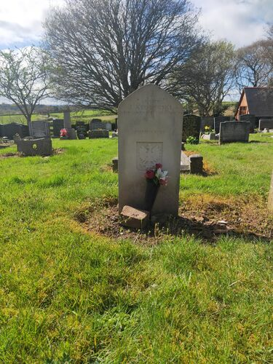
Korean War
James Henry Williamson Died 1951 aged 35. Sergeant Royal Northumberland Fusiliers. His Service Number was 4269659.
James Henry Williamson, born 20 May 1915, Stoke Newington, London. He enlisted with the Northumberland Fusiliers, 29 December 1933, aged 18 and served 3 tours abroad with them in Egypt, Palestine, The Middle East, The Far East. He married Rose Anne Beatty 14 July 1945 at St. Werburgh’s Church, whilst he was stationed at Blacon Camp. Shortly after their marriage he was posted to Gibraltar, returning to England before the outbreak of the Korean War. He re-enlisted to serve in that war. He died during the 3rd Battle of Seoul, 2 – 4 January 1951. James, died 3 January is commemorated at the UN Memorial Cemetery, Pusan, Korea, Grave number, 1737. He is also remembered on a family grave in Overleigh Cemetery. War time deaths of Beatty family members. Rose Anne’s father Hugh, was one of three Beatty brothers of the parish who gave their lives during the Great War.
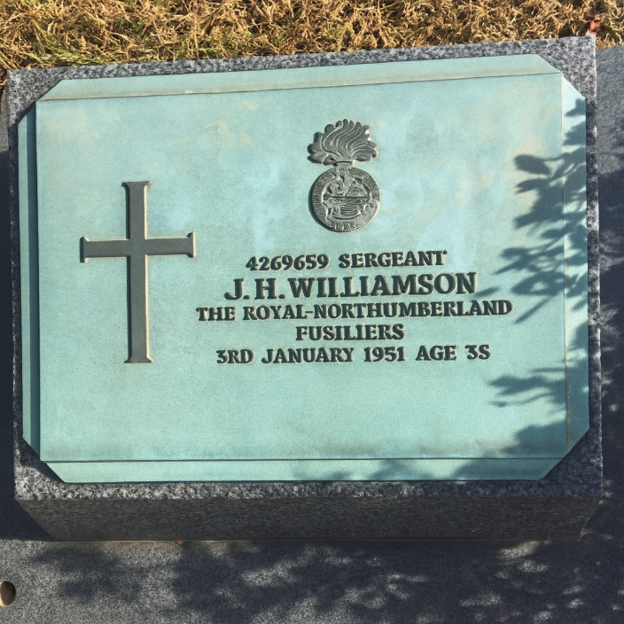

Northern Ireland

Peter John Willis Died 1975 aged 37. Major Green Howards
Peter John Willis, son of George H Willis and Catherine Nora Moynihan, born Great Ouseburn, Yorkshire. Major Peter Willis was a British Army officer who tragically lost his life during the Troubles in Northern Ireland. On July 17, 1975, Major Willis, serving as the Green Howards company commander in Crossmaglen, was investigating a milk churn at Cortreasla Bridge in Tullydonnell. Accompanied by three British soldiers, all of whom were bomb disposal experts, they walked through a gap in a hedge beside a signpost. Unbeknownst to them, a 70 lb bomb had been packed into a beer keg and buried in the ground. The bomb was detonated by command wire from about 400 yards away, resulting in the tragic loss of life. Four soldiers were killed outright, and another was injured by shrapnel. The soldiers killed alongside Major Willis were Edward Garside, Robert McCarter, and Calvert Brown. This devastating attack marked the first major breach in the truce negotiated by the IRA and the British government earlier that year. Major Peter Willis and his comrades were the first British soldiers to be killed by the IRA since the February truce. The IRA claimed that the attack was retaliation for the killing of two IRA members.
At the time of his death, the Green Howards were based at the Saighton Camp. His requiem mass was held at St. Francis. 6 men from his unit flew back to Chester to act as pall bearers at his funeral. A telegram of sympathy was sent by King Olaf of Sweden, the Colonel in Chief of the Green Howards. Major Willis is buried at Blacon Cemetery.
Michael Joseph Anthony Larkin Died 1977 aged 23. Sapper Royal Corps of Engineers. His Service Number 24218383.
Michael, son of Anthony Larkin and Theresa Wallace, born in Nenagh, Tipperary, Ireland. He was the youngest of 3 brothers and a sister. Educated at St. Werburgh’s and St. Bede’s Schools. Michael had been in the Royal Engineers for seven years having left school, serving in Germany, Gibraltar and the Sudan. He had spent the last two years in Ulster and extended his service for another three years and was going into the commandos. He was found dead, 9 February 1977, in the Palace Barracks in Holywood near Belfast. Fr. Peter Sharrocks performed his funeral service at St. Werburgh’s and he was interred in Blacon Cemetery.
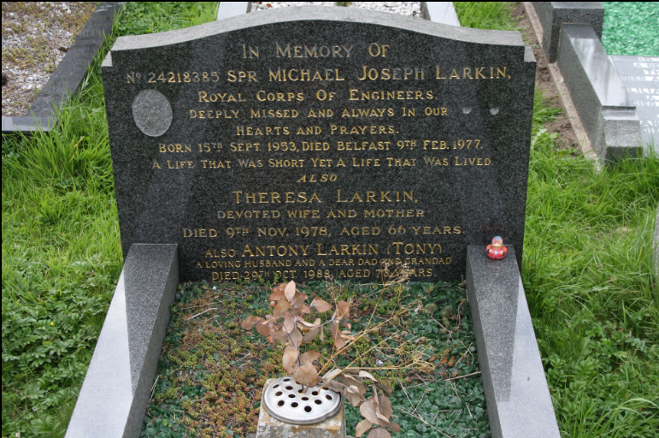
Stephen Burroughs Died 1990 aged 30. Lance Corporal 1st Battalion, The King's Regiment. His Service Number 24218383.
Stephen, son of Ralph Burrows of Nelson, Lancashire was born in Burnley in 1960 and then grew up in Blackpool. He joined the Kings Regiment and rose to the rank of Lance Corporal. He met his wife, Jane Sanby when the regiment was stationed at the Dale Barracks. The Kings Regiment was stationed at the Dale Barracks for three years before the Ulster tour of duty. The couple married at St. Werburgh’s Church in May 1986. Ralph died 24 October 1990 whilst on his third tour of duty in the province. He had hoped to leave the army at Christmas to start a new life on his in-law’s farm at Tarporley.
Lance Corporal Burrows was one of 5 members of his unit killed at an army checkpoint (Victor 2) on the Buncrana Road at Coshquin on the border between Londonderry in the UK and Donegal in Republic of Ireland. A 1,000 lb. van bomb, driven by an innocent man whose family were being held hostage by the provisional IRA, was detonated at the checkpoint, killing the driver and the soldiers and injuring many more. Canon Vincent Turnball officiated at his funeral at St. Werburgh’s Church, he was buried at St. Helen’s Parish Church, Tarporley.
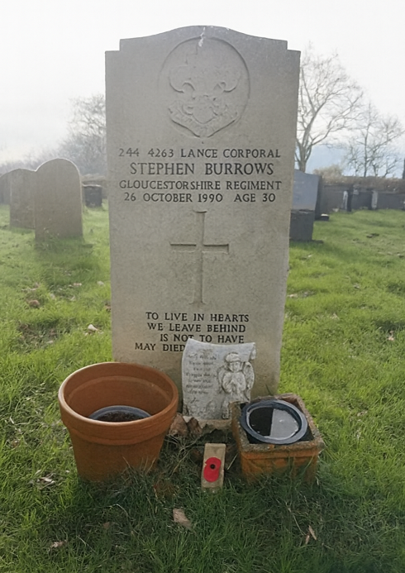
Stephen James Healey Died 2012 aged 29. Captain 1st Battalion, The Royal Welsh (The Royal Welch Fusiliers). His Service Number ***.
Stephen James Healey, son of John and Kerry Noctor, born 19 September 1982 in Cardiff, Wales. Football was a key part of his early life and Stephen aspired as a child to become a professional footballer. He had an apprenticeship with Swansea City and was with the club for a couple of years, where he played at centre back. But his footballing career was cut short after he suffered a number of injuries.
He then decided to go to university and even though he did not have any A levels, he was accepted by Swansea University on a degree course in sports science based on his experience as a footballer. Whilst at university, Stephen decided that the British Army would be his new career path. He joined the Army in 2007, choosing the officer career path, he first attended the Royal Military Academy Sandhurst in Berkshire, England. He was then commissioned into the Royal Welsh Regiment. Stephen’s first tour in Afghanistan ran from December 2009 to April 2010. In January 2010, while leading a vehicle convoy Stephen survived an improvised explosive device (IED) attack on his Mastiff PPV (Protected Patrol Vehicle).
Having returned from Afghanistan, in Summer 2010, Healey and another Lieutenant led a group of 26 soldiers of 1 Welsh on a 224 miles (360 km) charity run across Wales. The run started in Chester on 22 June and finishing in Cardiff on 26 June, crossing the line on Armed Forces Day, which was being held in the city. It raised funds for the Army Benevolent Fund, the visually impaired soldier’s charity St Dunstan's, and their colleagues injured in Afghanistan.
Stephen Healey received a Mention in Despatches, announced in the Operational Honours and Awards list of 24 September 2010 and was promoted Captain. Before leaving for his 2nd Tour in Afghanistan, Stephen organised another charity event, raising money by walking blindfolded from the barracks in Chester to Llandudno, Conwy.
The 1st Battalion redeployed to Afghanistan arriving on 9 March 2012 as part of 12 Mechanised Brigade. Stephen was in command of the 1st Battalion Royal Welsh reconnaissance platoon on patrol in the Nahri Saraj District of Helmand province, Afghanistan, when his vehicle was blown up by an improvised explosive device. He was given first aid on scene, before being flown to the military hospital at Camp Bastion where he was confirmed dead on arrival. He died, 26 May 2012, 78 days into the tour. His commanding officer Lieutenant Colonel Stephen Webb MC, said he would be remembered "as one of the most charismatic and professional leaders any of us will have had the privilege of serving with." His funeral service, with full military honours, was held on 15 June at St Cadoc's Roman Catholic Church, Llanrumney.
https://www.findagrave.com/memorial/90856921/stephen-james-healey
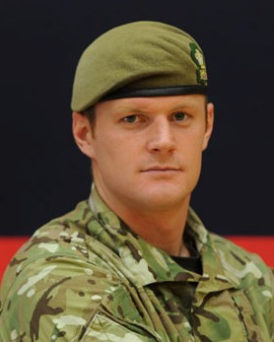
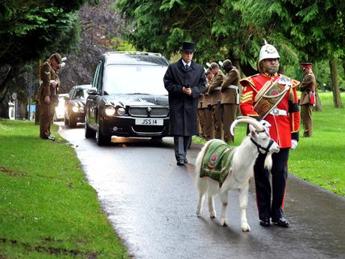
Corporal Michael John Thacker, Died 2012. Corporal 1st Battalion, The Royal Welsh (The Royal Welch Fusiliers). His Service Number ***.
Michael John Thacker, son of *** and Alison Brazier, born 1 February 1985 in Swindon, Gloucestershire.
Corporal Thacker was born in Swindon but spent most of his childhood in Cwmbran when the family moved to Wales. He was a keen rugby player playing for Cwmbran RFC until the age of 12. Michael joined the army in 2004 following in the footsteps of his uncle and grandad who had both served in the forces. He completed basic training aged 19 at Catterick and spent time in Aldershot before serving in Iraq in 2004 and South Armagh in 2005. Michael and his brother Lance Corporal Matthew Thacker, were stationed in Chester, serving in the same regiment but in different companies. He was recovering from a serious knee injury prior to his third tour of duty in Afghanistan. Recently promoted, he was considered an outstanding leader with a bright future in the Fire Support Company.
Before his final tour to Afghanistan, Cpl Thacker met his wife Catherine through the army when she was an army medic.
Michael died 1 June 2012, Nahri Saraj District, Helmand, Afghanistan. He had just finished patrol and gone back to base when he was killed by small arms fire while manning observation post “Tir”. He was evacuated by helicopter but died of his injuries. A funeral with full military honours was held for Michael on June 25, 2012 at Coventry Cathedral. He is remembered at the Heart of England Crematorium, Nuneaton, Warwickshire.
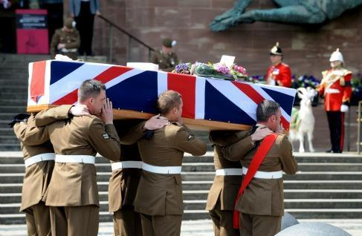
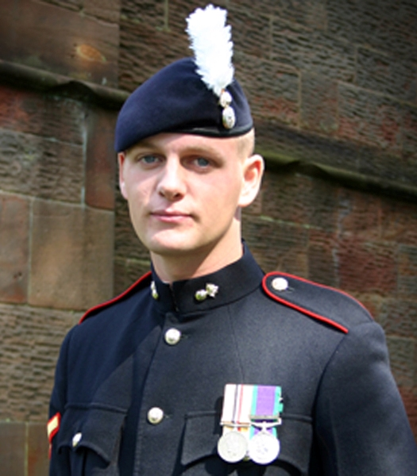

Cheshire Observer 18 Apr 1942 Page 6 Col 6
Cheshire Observer 19 Aug 1944 Page 8 Col 3
Cheshire Observer 23 May 1936 Page 13 Col 4
Cheshire September 14 Nov 1940 Page 5 Col 6
Cheshire Observer 15 Apr 1944 Page 5 Col 6
Chester Chronicle 1 Jul 1944 Page 2 Col 5
Cheshire Observer 25 Nov 1944 Page 3 Col 4
Cheshire Observer 28 May 1960 Page 22 Col 2
Cheshire Observer 28 Apr 1945 Page 7 Col 3
Cheshire Observer 28 Apr 1945 Page 7 Col 3
Accident Handley Page Halifax Mk III NA500, Friday 12 May 1944 (flightsafety.org)
Web: UK and Allied Countries, Index of International Bomber Command Losses, 1936-1966
https://www.backtonormandy.org/the-history/air-force-operations/airplanes-allies-and-axis-lost/halifax/18572-NA5001944-05-12.html
Chester Chronicle 10 Jun 1944 Page 6 Col 5
Cheshire Observer 1 Jul 1944 Page 8 Col 6
Contemporary Biographics – Commercial Page 361
Cheshire Observer 20 Oct 1937 Page 16 Col 7
Liverpool Daily Post 9 Sep 1940 Page 3 Col 2
Chester Chronicle 6 Feb 1943 Page 8 Col 3
Chester Chronicle 6 Feb 1943 Page 8 Col 3
https://uboat.net/allies/warships/ship/3440.html
Ancestry UK, Commonwealth War Graves, 1914-1921 and 1939-1947
https://en.wikipedia.org/wiki/HMS_P222#/media/File:HMS_P222.jpg
Chester Chronicle 23 May 1942 Page 6 Col 2
https://racmp.co.uk/wp-content/uploads/2021/02/HMS-Trinidad-The-Ship-That-Torpedoed-Itself.pdf
https://www.world-war.co.uk/trinidad_loss.php
Cheshire Observer 11 Nov 1944 Page 7 Col 6
RAF St Eval - Wikipedia
UK, World War II Index to Allied Airmen Roll of Honour, 1939-1945
Chester Chronicle 19 Sep 1942 Page 6 Col 4
https://wrecksite.eu/wreck.aspx?15511
Chesire Observer 5 Oct 1946 Page 7 Col 4
War in the Balkans, 1941-45 | National Army Museum (nam.ac.uk)
Cheshire Observer 26 Aug 1944 Page 3 Col 2
https://www.cwgc.org/find-records/find-war-dead/casualty-details/2062777/frank-reade/
Western Mail 6 Sep 1943 Page 3 Col 3
Royal Artillery Attestations 1883-1942
Cheshire Observer 5 Jun 1943 Page 6 Col 4
UK, World War II Allied Prisoners of War, 1939-1945 for Robert F. Tyrer WO 392 POW Lists 1943-1945 26: British Prisoners of War Held in Japan or Japanese-Occupied Territory: R - Z
Find My Past --Robert Frederick Tyrer in 1941 Prisoners Of War 1715-1945 Japan
Robert Frederick Tyrer in the UK, Commonwealth War Graves, 1914-1921 and 1939-1947
UK, Army Roll of Honour, 1939-1945
https://en.wikipedia.org/wiki/Layforce
https://thejoesmoechester.wordpress.com/2015/06/14/where-did-the-bombs-drop-during-wwii-in-chester/
Ancestry UK, World War II Civilian Deaths, 1939-1945 – County Borough of Chester
Cheshire Observer 30 Nov 1940 Page 2 Col 4
History of Barrowmore - Barrowmore Ltd
Ancestry William J Cuddy in the 1939 England and Wales Register – St Giles Hospital London
https://www.independent.ie/regionals/sligo/news/tragic-twist-of-fate-as-kind-act-had-fatal-consequences-for-local-woman-during-german-wartime-bombing/39643083.html
Air Forces WW2 Casualty : Starszy Szeregowiec Z KEDZIERSKI (P/784589), Polish Air Force [RAFCommands]
Cheshire Observer 20 Jan 1951 Page 7 Col 2
https://www.findagrave.com/memorial/160121785/james-henry-williamson
Chester Chronicle 18 Feb 1977 Page 3 Col 5
Chester Chronicle 2 Nov 1990 Page 19 Col 4
https://www.findagrave.com/memorial/164018406/stephen-burrows
https://www.findagrave.com/memorial/164018406/stephen-burrows
https://www.bbc.co.uk/news/uk-18232087
freepressseries.co.uk/news
https://www.findagrave.com/memorial/91423716/michael-john-thacker John W. Curtis and Jim Strain 2025

