Fr. Joseph Irish
This story started from reading a short brief on the life of the above priest found in “To Preserve their Memory, Shrewsbury Diocesan Priests, (Deceased) 1850 – 2001”. The entry for Joseph Irish shows that he was the son of Joseph and Mary Jane Irish (Gartland), born 19 Jan 1906, Latchford (Warrington). He was educated at St. Francis Xavier College, Liverpool, from 1921 and continued his training for the priesthood at Ushaw, which he completed in 1932. He was ordained by Bishop Moriaty at Our Lady, Latchford 24 Jul 1932. His career as a priest then started, curate at Chester St. Werburgh 1932-34, curate at Stockport Our Lady. 1934-35, curate at Liscard 1935-1940. He then returned as curate at Chester St. Werburgh 1940-41. In 1941, he left St. Werburgh to become a Chaplain of the Forces 1941-46. The entry also states during the liberation of Europe he served as chaplain to the Duke of Lancaster’s Own Yeomanry. This service was rewarded with decorations for gallantry when he received the Belgian Croix de Guerre with Palm and the Belgian Chevalier with Honour of Leopold 2 with Palm. His war time experiences must have served him well as on his return he was promoted to be the first Parish Priest at Alderley Edge.
What was the backstory of this forgotten St. Werburgh’s curate, who left the parish in 1941 and served with the army until 1946. Certainly, he would have been supported in this move by his Parish Priest, Canon Hayes who had been curate at St. Werburgh’s 1899-1917 before returning later as Parish priest. Canon Hayes experiences in Chester in the Great War would surely make him receptive to someone wishing to serve as Chaplain to men serving away from home.
Why did Fr. Irish receive two Belgian Awards for gallantry. This essay seeks to bring to life the work undertaken, the experiences of Fr. Irish in his service during this war time period when he left St. Werburgh. Much of the information on his experiences has been gained from the Regimental History of The 77th (Duke of Lancaster’s Own Yeomanry), Medium Regiment, Royal Artillery with whom he served.
As a Chaplain, Fr. Irish was automatically credited with the rank of Captain. Training for Padres and Doctors is provided by attendance at a common commissioning course at Royal Military Academy Sandhurst. During the Second World War in the UK, Army chaplains were trained at various locations. Training included preparing chaplains for the unique challenges they would face in providing spiritual and pastoral care in a wartime setting.
Fr. Irish’s army records show his initial training was undertaken with the Scottish Command. The training was in two parts, attendance at 75th General Hospital, Peebles, together with secondment to different army units, e.g. 235 Searchlight Training Regiment, time spent at HQ, 2 Heavy Anti-Aircraft Regiment and No 1 Infantry Depot.
On 1 Dec 1943, Fr. Irish was transferred with 75 General Hospital to 21st Army Group in England in preparation for the invasion of Europe. 11 Feb 1944 he was attached to 8th Army Group Royal Artillery (AGRA), 117th Field Regiment RA. and then to 25th Field Regiment RA, 30 Apr 1944. It was with the 25th Field Regiment RA that Joseph Irish embarked for Normandy on the 19th June 1944. He remained with them until 31 Oct 1944 when he was transferred to the 77th Duke of Lancaster’s Own Yeomanry Medium Regiment, Royal Artillery, where he remained until 31 Oct 1945. On the 22 Oct 1945, well after the war had ended, Fr. Irish volunteered to serve for a further year.
The Belgian Embassy was contacted and their archives checked to find if they had any details of the awards. Unfortunately, the relevant file had not been kept so no details of the background to the Belgian awards was found. The Belgian Government also awarded decorations for gallantry to foreign troops which were handed to the various military powers who then made the allocations, often without citations. It is therefore likely Fr. Irish’s awards were in this category.
Both Belgian awards included with Palm. Avec palms is the equivalent of the British mention in despatches. A bronze palm leave is attached to the medal for anyone who has been mentioned at ‘Army’ level. His awards from Belgium were gazetted in the London, Gazette Date of announcement in London Gazette: 08 December 1945.
The Army recommendation for Joseph Irish dated 25 Oct 1945 is retained by the National Archives at Kew . It states “Father Irish has been RC padre to 8 AGRA throughout the operations of the BLA (British Liberation Army). During the early operations casualties were considerable. Father Irish was always to be found in the most dangerous locations helping with the wounded and encouraging with cheerful words those who were left to carry on with their tasks quite regardless of the church to which they belonged.” Recommend by A. R. Campbell, Brigadier Commander 8 AGR, Authorised by E. H Barker, Lieutenant General Comd. 8 Corps Dist.
The records of the 25th Field Regiment RA are not readily available. However, the 77th Duke of Lancaster’s Own Yeomanry Medium Regiment, Royal Artillery, the second regiment he served with, have produced 3 documents on their NW Europe campaign 1944-46. The picture below shows the route the 77th DLOY followed as part of the Liberation Army. The 25th Field Regiment RA would have followed a very similar route.
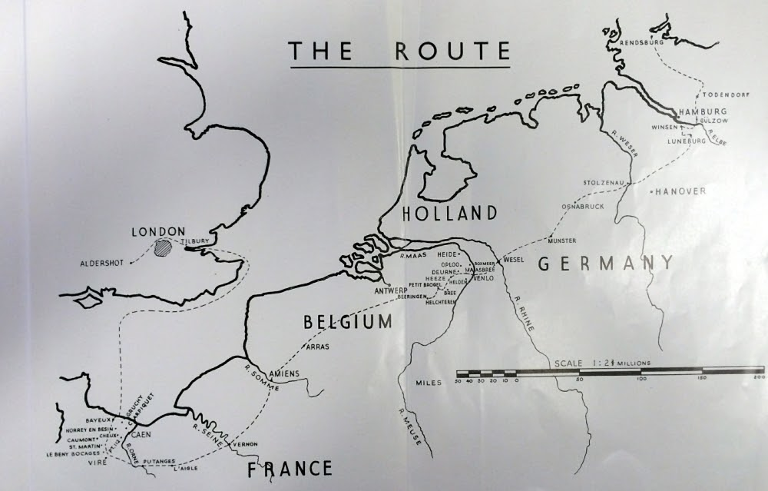
Some of the events that Fr. Irish would have experienced can be found in Hugh Gunning’s notes on this period and the campaign records of the DLOY. The initial breakout from the Normandy beachhead took much longer than originally envisaged. By the 17th-24th June the regiment was in position but found the local inhabitants treated the liberation army with great reserve as they feared the return of the German Army and consequent retribution. The Luftwaffe carried out occasional offensive sweeps. The regiment was well protected by Bofors guns of a neighbouring Anti-Aircraft (AA) unit and the DLOY’s own (AA) Bren Gunners who were only to keen to join in the barrage. The Bren gunners proved overly enthusiastic and on occasion sprayed other allied troops whilst engaging low flying enemy aircraft. The DLOY decided to leave the aircraft to the Bofors gunners after receiving successive complaints from a neighbouring AA detachment that they invariably took cover when a hostile plane came over to protect themselves from DLOY bullets. Their cook pointed out that if any more of his dishes were perforated, he would be unable to produce another meal.
Another entry states, on the evening of 7th July the DLOY watched the one thousand bomber raid which preceded 1st Corp attack on Caen. Morale was said to be high after this their first view of a large-scale bomber raid. Throughout July the regiment was in continuous action as the army struggled to break out from Normandy beachhead. By early August, breakout from Normandy had been achieved and the unit pushed forward through country unmarked by war, villagers greeted the men with “Libre, Libre” and the vehicles were garlanded with flowers. Fierce battles then took place as the German army attempted to arrest the advance. The regiment was then ordered back for rest and refit joining with other Regiments of 8 A.G.R.A. who had dropped out of the battle after the liquidation of the Falaise pocket.
Fr. Irish would have witnessed the liberation of northern France, followed in early September, the liberation of Belgium, then Holland. On 31st Oct 1944 transferred from the 25th Field Regiment RA to the 77th Medium Regiment DLOY. It was with the DLOY that he finally entered Germany on the 25th March 1945, supporting airborne landings and the crossing of the Rhine at Wesel. The prelude to the attack was an intense bombing raid on the town. DLOY records indicate the level of destruction caused by the bombing raid, acres of housing had been raised and the few remaining roads bearing no resemblance to the maps provided, having been produced by bulldozers that morning. By the beginning of April, DLOY had entered Munster where a Military Government was established. DLOY guns were no longer required and the regiment was used in a policing role dealing with the large numbers of released slave workers. A Displaced Persons Camp (DP’s) had been set up that contained 6000 DP’s, mainly Russians, with the numbers growing daily as more arrived from local farms, camps etc. DLOY were relieved of this occupational phase on the 27th Apr 1945 and returned to active duty on 28th Apr on the drive towards Hamburg. Hamburg surrendered on the 3rd May one day before the news of the capitulation of all German armies on the British Front on the 4th May. By the 8th June the regiment said farewell to their guns. The role of the army now changed to that of an occupation army having to restart services etc. for the civilian and displaced persons in their area of control.
The DLOY was based at Eider Barracks, Rensburg on the Kiel Canal where they acted as Garrison Regiment. Their duties were many, establishing control of the Kiel Canal, disarming Wehrmacht prisoners, centralising and evacuating French, Belgian, Dutch, Czech, Russian etc. displaced persons. On the 22 Oct 1945 Fr. Irish volunteered to serve for a further year with the army. Then, 31 March 1946 he was transferred to the British Army of the Rhine 67th British General Hospital and on 28th May 1946 left Rensburg and was transferred to Headquarters at Hamburg. He returned to the UK 9th Oct 1946 and left the army a day later.
Fr. Irish never did return to St. Werburgh’s, Chester. Upon his return, Bishop Moriaty appointed him to serve the small catholic community in Alderley Edge. It is believed the first mass in Alderley Edge, since the reformation took place in 1942 when the Sisters of Joseph of the Apparition bought a house there to serve as a convent for training nuns. The Convent Mass was said by Salvatorian Fathers based in Macclesfield. When he arrived in Alderley Edge, Fr. Irish asked another recently discharged soldier, Arthur Boyce, to help start a parish and help prepare children at a local school for Holy Communion and Confirmation. Regular mass attendance was only about 20. When contacted, Bishop Moriaty indicated there would need to be a regular attendance of 50-100 parishioners for a new Parish to be created in Alderley Edge. This was soon achieved and as the Mass numbers exceeded those who could attend the convent chapel, the order consented to a mass centre being opened in a room at the back of the school. Fr. Irish remained as parish priest at Alderley, until 1948. He then moved to Congleton 1948 – 52 and Hyde, 1952 -63, where he died after evening mass 6 Sep 1963.
Photographs below are of Fr. Irish when taking up his position as curate at St. Werburgh’s, Chester, 1940 and in his military uniform as a Chaplain to the Armed Forces, 1941-46.
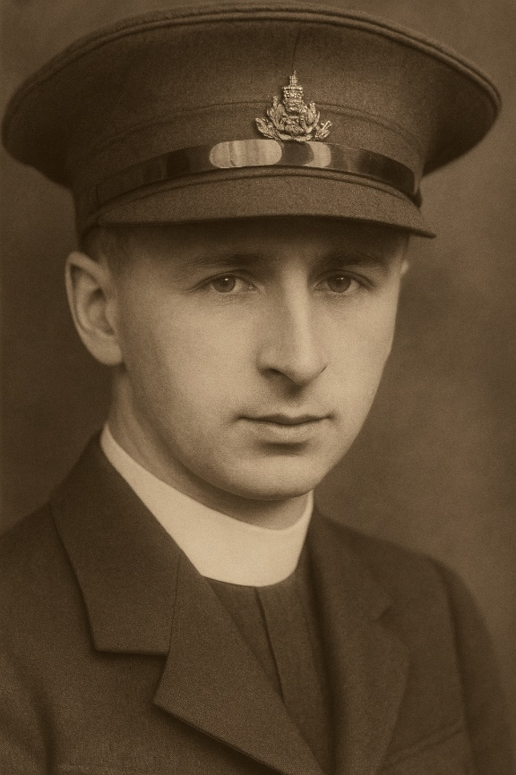
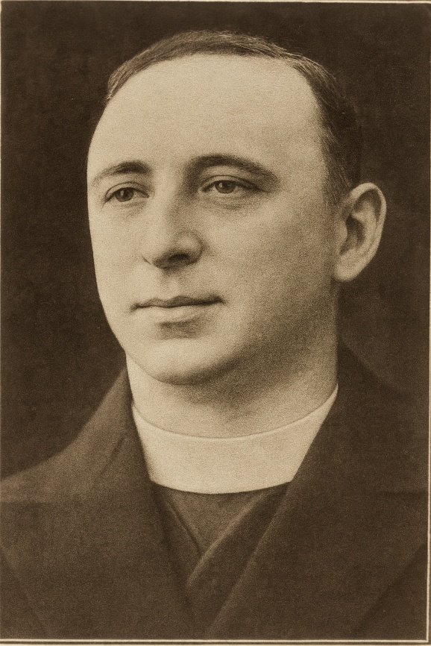
Chester Chronicle 13 April 1940 Page 11 Manchester Evening News 25 March 1946 Page 3
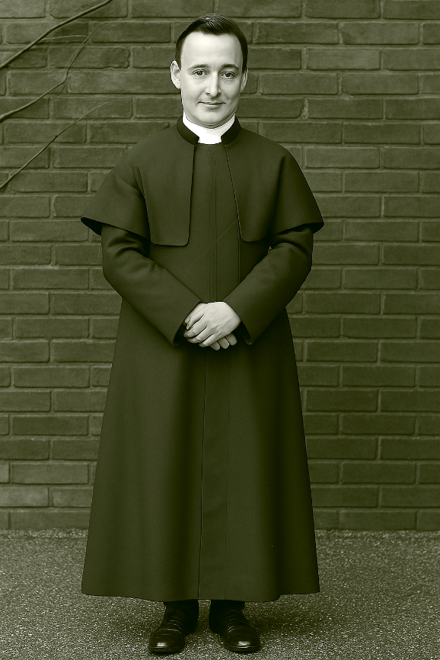
Fr. Irish photographed in front of the Presbytery Porch

To Preserve their Memory, Shrewsbury Diocesan Priests, (Deceased) 1850 – 2001
The 77th (Duke of Lancaster’s Own Yeomanry, Medium Regiment, Royal Artillery. North West Europe Campaign June 1944 – May 1945
E mail from Belgian Embassy, Berg Sven <sven.berg@mil.be> received 25/01/24
E mail from Belgian Archives, agr_ar_2 <agr_ar_2@arch.be> received 25/01/24
https://discovery.nationalarchives.gov.uk/details/r/D7399046
77th Duke of Lancaster’s Own Yeomanry Medium Regiment, Royal Artillery https://sites.google.com/site/dloythroughww2/77th-med-regt-ra/77th-nw-europe-campaign-1945-46-part- 1-3 77th Med Regt RA Notes from Captain Hugh Gunning Observation Officer 77th (DLOY) Med Regt RA
The website of St. Pius X Roman Catholic Church – https// About St Pius X Alderley Edge – St Pius X Alderley Edge (stpiusalderley.com)
John W. Curtis 2025

